ASE LAB ASSIGNMENT 8
IMPLEMENTING CRUD API USING MEAN STACK

Team: Srichakradhar Reddy Nagireddy (32) Sathwik(5)
Objective:
- Create a Library Management System with MongoDB as the backend database.
- Create a MongoDB resource and connect it to our application.
- Create a UI for the app.
System Configuration:
- Visual Studio Code
- Node
- ExpressJS
- Angular
- MongoDB
MongoDB setup:
- Created a MongoDB Atlas account in https://cloud.mongodb.com.
- Selected the cloud provider and region.
- created the cluster and Connection String.
- Created a collection and database for storing the data.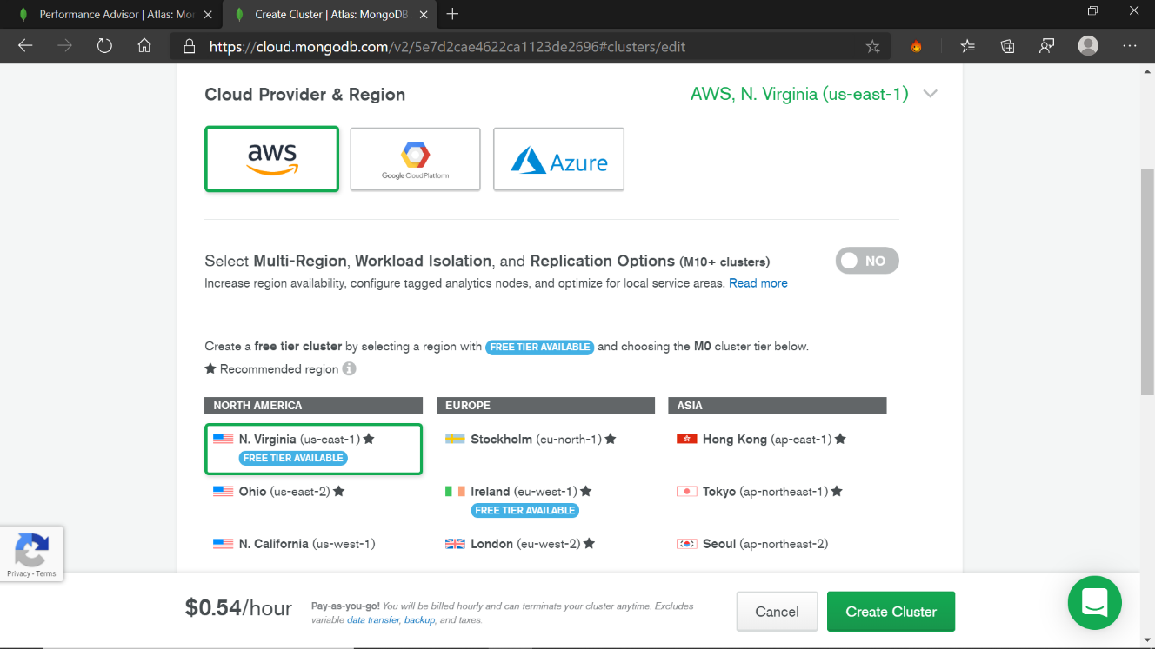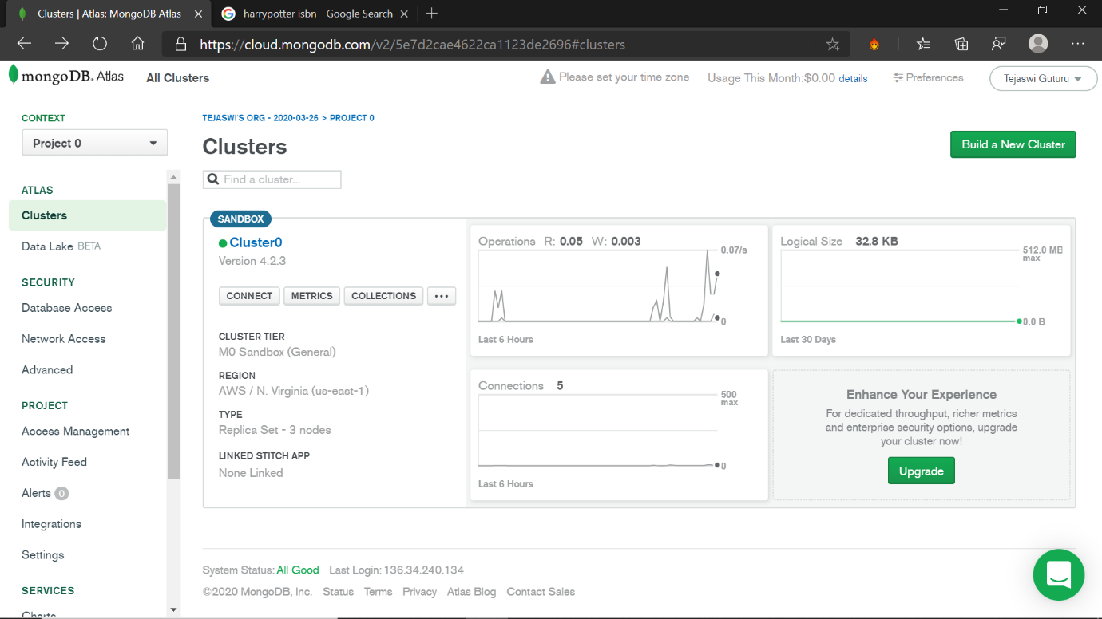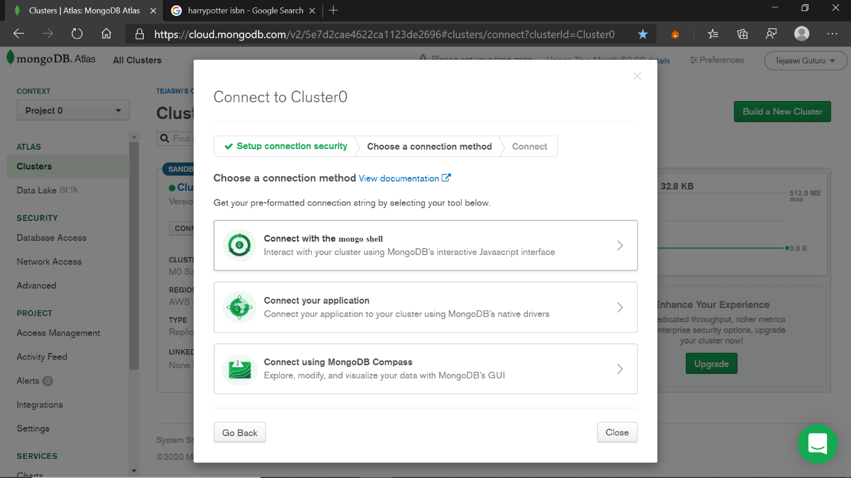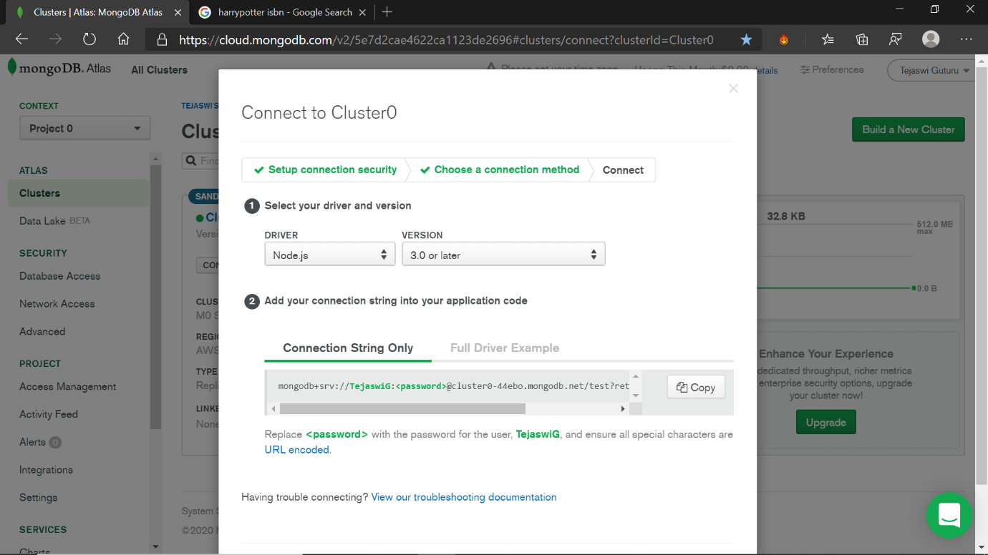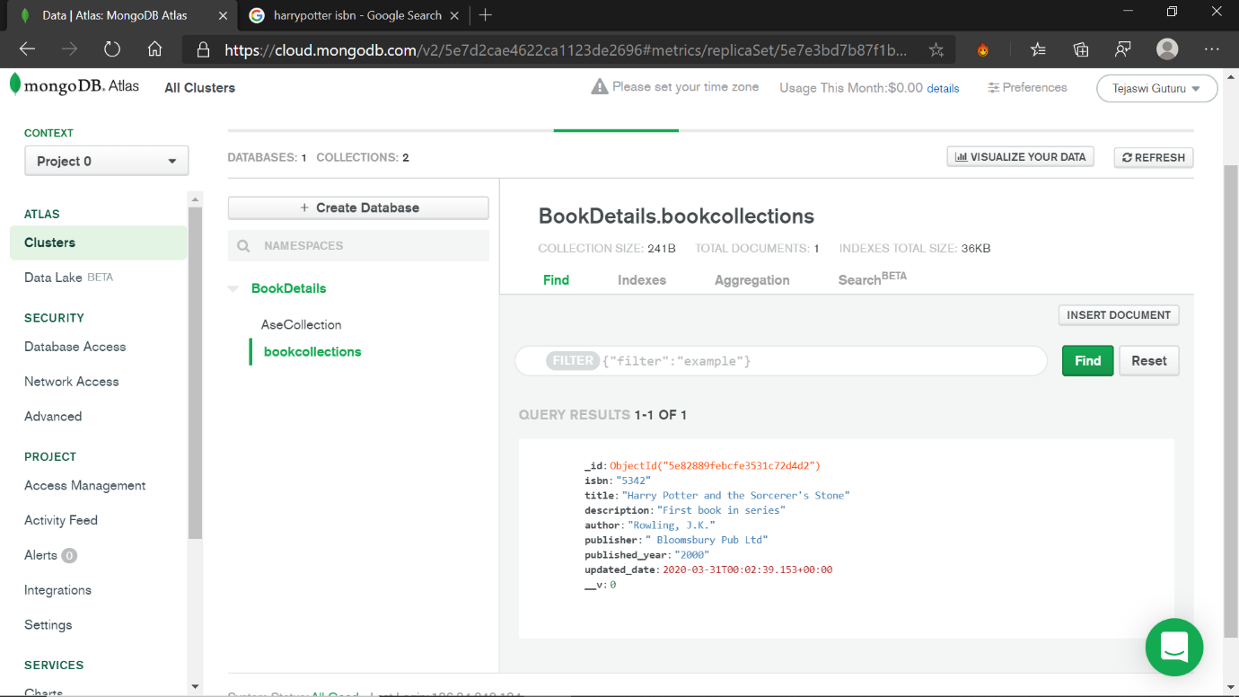

Connecting MongoDB and Customizing UI:
The Connection string is embedded in the app.js file in the application.
Routing configuration is modified in the app.module.ts file for the component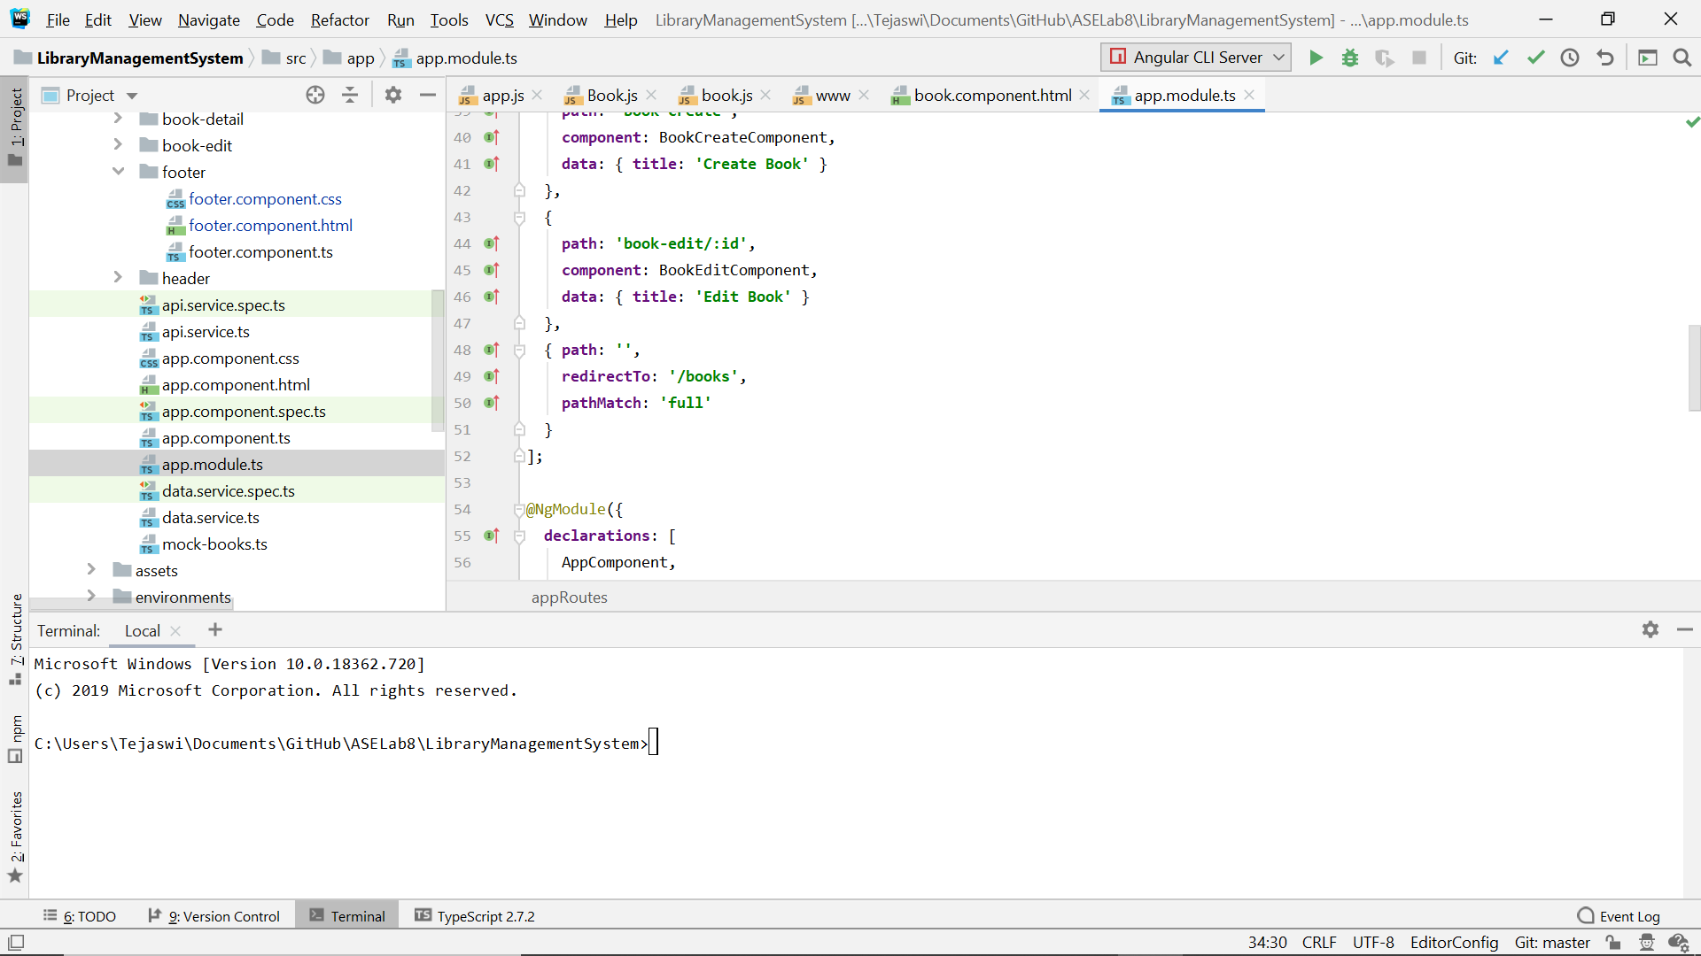
The UI:
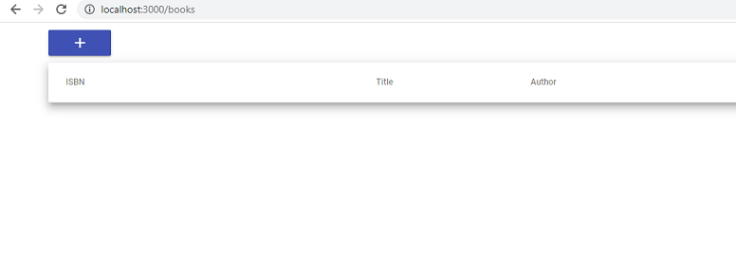
Create a new entry:
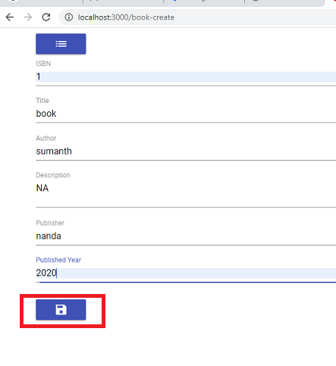

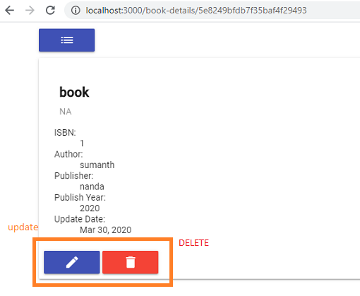
Edit or delete the entries using the buttons.

Review the entries.
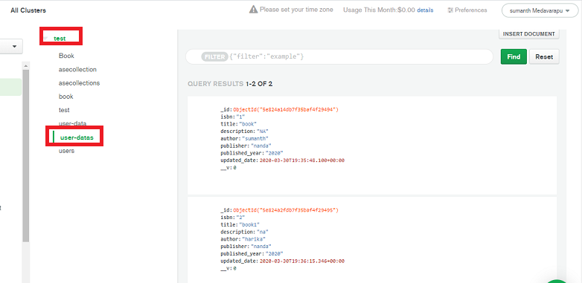

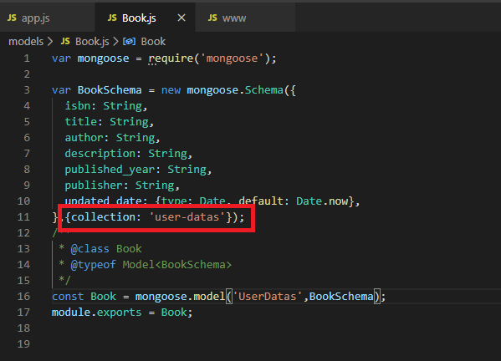

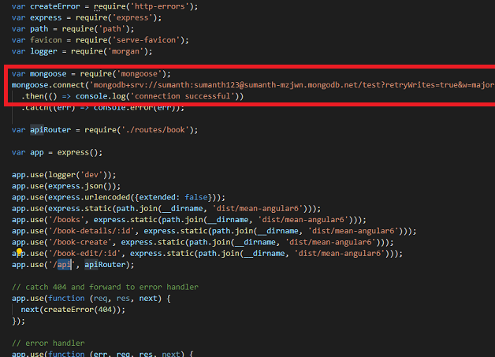

MongoDB BookDetails DB with both the documents